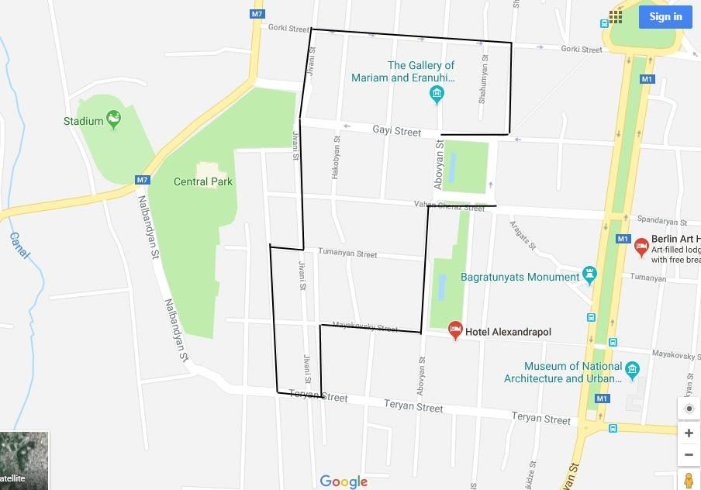

**Discover Gyumri with Armen**

History experience

Hosted by  Armen Hovsepyan

Location

Gyumri

Time

2 hours

Offered in English and in Russian

https://a0.muscache.com/airbnb/static/page2/icon-number-available-animated-074b392fde3b450acdc18e531e56ce61.gif

About your host, Armen Hovsepyan

I was born in Gyumri in 1988. After finishing my education in the US, I returned back to Armenia and founded Gyumri’s first travel website: www.travelgyumri.com, which provides the latest and most necessary information for the visitors traveling to Gyumri. Having the opportunity to be involved in Earth Watch expeditions for documenting Gyumri’s historic district, it created a unique chance for me to explore deeply the cultural values of the city and a chance to show it to foreigners. After a comprehensive research in Shirak region and Gyumri, I decided to show people the hidden treasures of the area rather than the classical everyday attractions. Shirak and Gyumri are filled with fascinating stories and places and most importantly with people who keep them alive. My goal is to involve as many local people as possible in my travel activities. Discover ancient traditions and preserved culture with us.

What we’ll do

This is an amazing opportunity to discover 18th-19th century unique and indigenous architecture, cuisine and the most hospitable people of Armenia’s cultural capital. This walking tour will help you discover more of the historic flavor of the city and the lifestyle of Gyumri people. Get to know the significant religious structures of the city, the Kumayri historic district, arts and crafts of the city.

What I’ll provide

Transportation

Lunch

Guide service

Who can come

Guests ages 12 and up can attend.

Notes

Wear long sleeves and comfortable shoes. We highly recommend that you bring sunscreen and sunglasses for protection. Also don't forget your camera, because this is an amazing ride for taking photos.